**COMPUTER NETWORKS**

**NAME: M.ISTAFA MALIK**

**ROLL: P190033**

**SECTION: BSCS-5A**

1. Setting Router Modes on 2600 Series Routers

Following shows the modes of 2600 series router

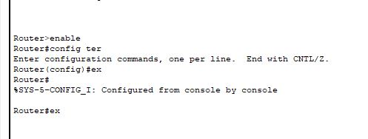

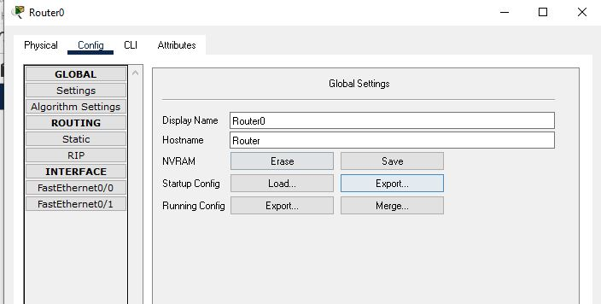

1. Changing Hostname of the Router

Click on router then go to Cli for to change the hostname using following commands.

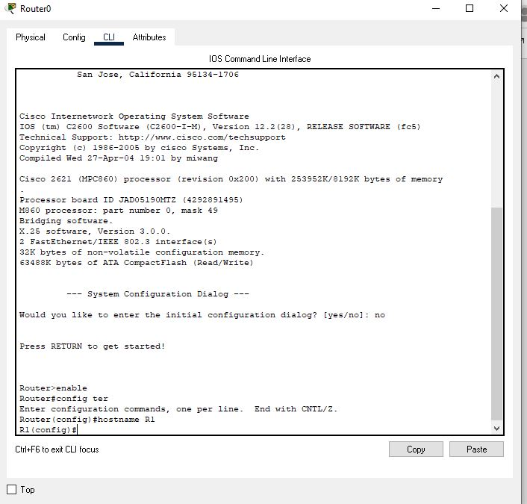

1. Configuring Date and Time on the Router (Clock Set Command)

Similarly use the following commands:

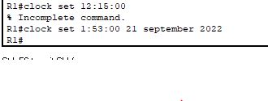

1. Setting a banner on the Router

To set a desired Banner use the following steps inside cli option of the router.

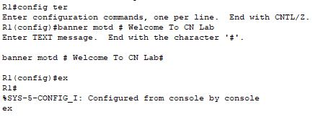

1. Displaying the Router’s Running-Configuration and Start-Up Configuration

Here are the Running and start-up configurations.

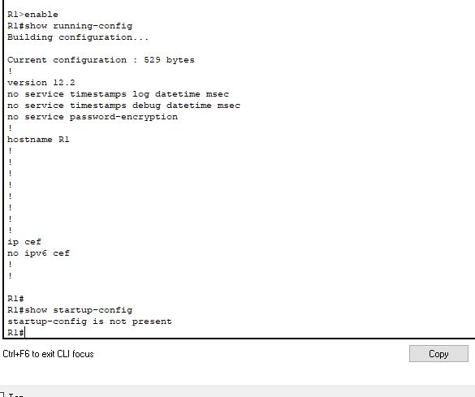

1. Enable Password and Enable Secret Password with the Encryption Techniques/Levels

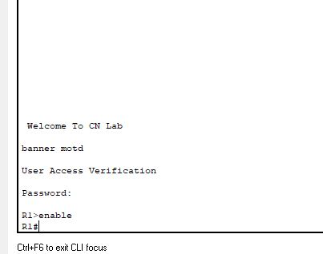

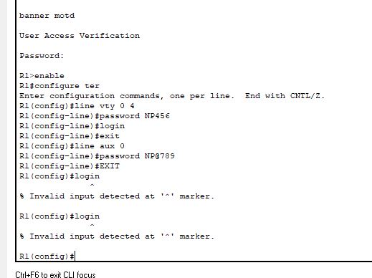

1. Line Console Password Implementation on CISCO 2600 Series Router

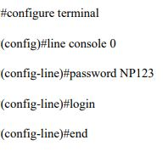

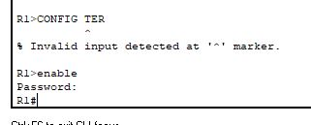

1. What is Telnet? How to Telnet? + Line VTY/Telnet Password

Telnet is a network protocol used to virtually access a computer and to provide a two-way, collaborative and text-based communication channel between two machines. It follows a user command Transmission Control Protocol/Internet Protocol (TCP/IP) networking protocol for creating remote sessions.

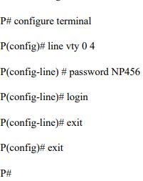

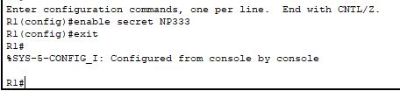

9. Usage of Router with different topology.

